Competencies and Skills  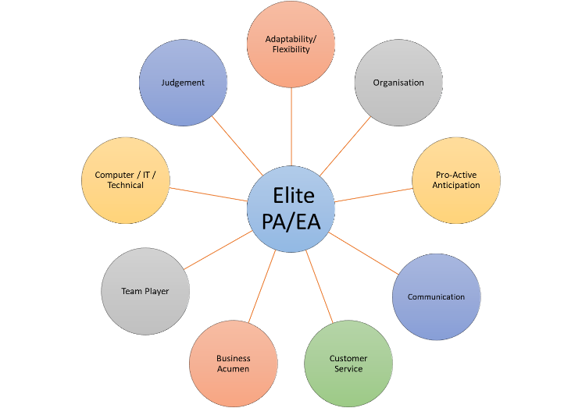  Shaping Behaviour  Four general intents shape behaviour. People behave based on intent. Here are four general intents that shape behaviour:  - Get the task done. When you really need to get something done you tend to speed up rather than slow down, to act rather than deliberate and to assert rather than withdraw. When a task is urgent you may become careless and aggressive, leaping before you look and speaking without thinking first.  - Get the task right. When getting it right is your highest priority you will likely slow things down enough to see the details, becoming increasingly focused on and absorbed in the task at hand. You will probably take a good long look before leaping if you ever leap at all.  - Get along with people. When there are people with whom you want to get along, you may be less assertive as you put their needs above your own.  - Get appreciation from people. Getting appreciation from people requires a higher level of assertiveness and people focus to be seen, hear, and recognised. The desire to contribute to others and be appreciated is a powerful motivation.  Difficult and Demanding Managers  7 Types of Difficult Managers and Colleagues to Manage  Bulldozing Expert Know-It-Alls equate accuracy and thoroughness with competence, are unforgiving of minor errors and tend to have little understanding or patience with what they perceive as the less logical aspects of human behaviour such as feelings, wishes and intuitions.  Power-Clutchers, Paranoids and Perfectionists are usually the results of the complexity of motivations. There are several common reasons why some managers hold the reins too tightly: a need to be certain, lack of confidence and trust, an irrational search for perfection and an over-strong wish to be in charge.  Super-Delegators are mistakenly confident for first-rate managers because they are super delegators. They often blame their subordinates for missed steps, late or incomplete assignments or lack of follow through.  Wafflers are supportive but fail to stand up for themselves. Wafflers simply want to be liked, approved of and accepted by everyone, so when their managerial role pushes them to do things that are likely to make them unpopular, they panic.  Stallers have high standards and concern for the welfare of others. They are immobilised by conflict. They seldom breach a topic that will provoke a strong negative reaction.  Fire Eaters are characterised as irritable, moody, hot-tempered and explosive. Fire Eaters’ sudden and often seemingly unprovoked outbursts are the product of two simultaneous events: feeling personally threatened while feeling under pressure to take some sort of action.  Ogres openly attack, with little provocation, driving their victims into silent confusion or speechless rage. | Negotiation  Should I negotiate or say NO to the task?  Not all requests should be negotiated. Here are some key questions to help determine if I should say NO to the task or negotiate.  - Do I have time to do it?  - How urgent/and or important is it? (Covey’s Prioritisation Matrix)  - Am I the right person for the task?  - Is someone else best suited for the job?  - Does this request fit with my goals, objectives, job responsibilities?  - Create an Action/Priority Matrix to determine fit.  Should I say YES to the person but NO to the task?  To help you say YES to the person but NO to the task you need to get creative and work out a viable solution by answering these three main questions:  - What does this person really need?  - Find areas of flexibility  - Determine priorities  - How else can this person’s needs be met?  - Find a different frame of reference or approach to the problem  - Look for time and resource alternatives  - How can I support this person to have their needs met?  - Define the larger goal  - Look for common interests and needs  Successful Delegation  Social Media Management  9 Steps to help you manage social media  - What to say  - How often  - Dealing with negative comments  - Do I need to check with anyone?  - Using photos/videos – rules  - Sharing information  - Engagement  - Monitoring  - Physical posting vs auto posting  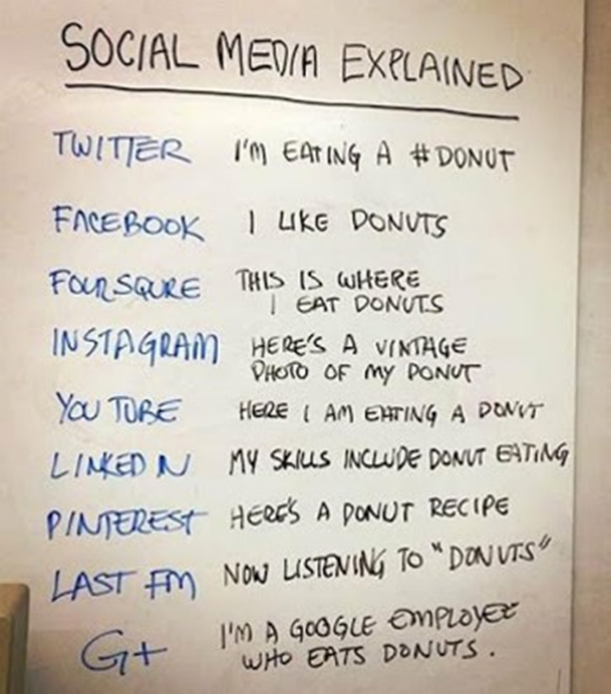  Mindfulness  Mindfulness is the ability to single pointedly rest our awareness in one place for an extended period without it falling under the influences of either excitation or dullness.  Three main qualities:  R – relaxation – settling the body in its natural state  S – stillness – avoiding any unnecessary movement to assist in settling the mind  C – clarity – careful, focused attention on the mind itself, moment by moment

