Make It Stick
Activity Pack

Advanced Skills for Elite PAs and EAs

Helping lessons learned through training become part of how we work.

To the Learner Leader…
This suite of activities has been designed to reinforce the key learning from the Advanced Skills for Elite PAs and EAs course. They have been designed to be led by team leaders or designated trainers and do not require training experience, though for best results we recommend that whoever is leading the activities understands the principles of adult learning and has some experience in leading learning activities.
The suite of activities will provide you with up to six months of learning reinforcement. We recommend that an activity is run each month following the Advanced Skills for Elite PAs and EAs course.
When running each activity:
- Ask the group to reflect back on the original course they attended:
  - What takeaways did they have?
  - What have they tried to implement?
  - When revisiting some of these activities for a second time, ask them what additional ideas or thoughts they have in applying the concepts and tools in the activities to their job.

Each activity will take 10-15 minutes to run depending on the size of the group.
There is one activity to a page. Each activity has a brief introduction followed by instructions for the trainer.
We suggest the following to optimise your learning experience:
- Have the group meet away from their normal workspace
- Make sure mobile devices are switched off so that everyone fully engages
- Make the environment ‘safe’ and encourage everyone to contribute
- Run these activities with everyone standing – try running them outdoors in the fresh air
- Have other team members take the lead and run an activity – this will build confidence and leadership skills
- Don’t be afraid to improvise – the learning needs to be about you and your group so make it meaningful
- When debriefing an activity, get the group to reflect on what the activity means for them and what they will do differently or continue to do that underscores the learning points from the activity
Activities in this pack
- Effective communication
- Dealing with your boss’s derailers
- Negotiating with your boss
- SMARTER delegation
- Responding to social media
- Managing stress

Activity 1: Effective communication
Introduction
The REACH profile can provide you with tips on how best to communicate with different personality types. It is important to understand that such behaviours are indicative and not absolute.
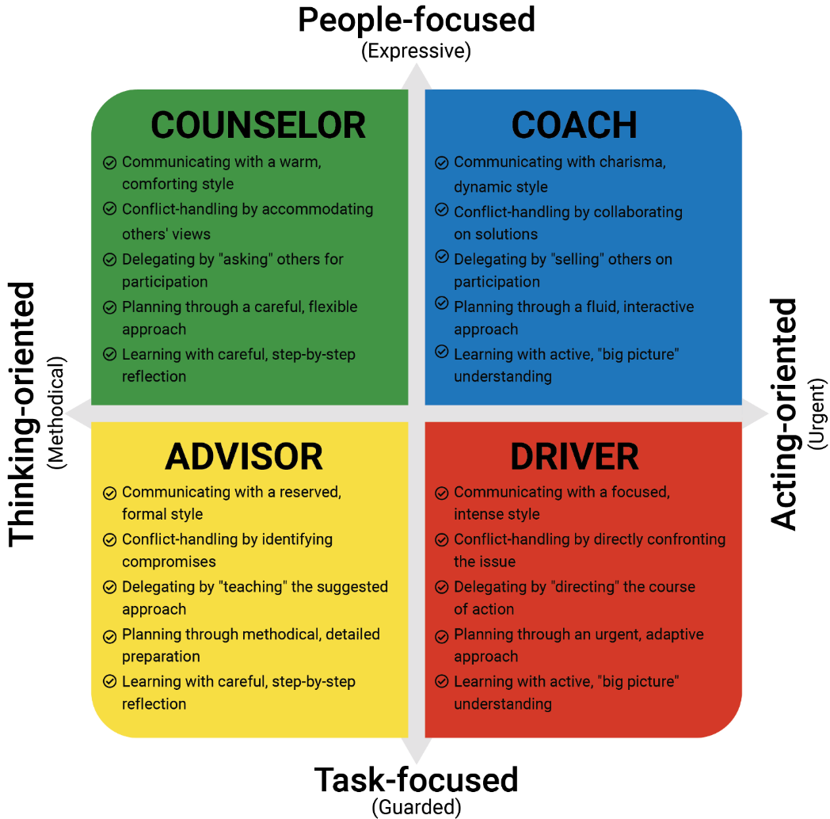
Instructions
Ask each person in the group to describe one communication challenge they have with a manager. Go through the following steps for each challenge raised:
- Characterise the manager’s behaviours according to the REACH quadrants
- Determine where the participant and the manager sit on the REACH matrix relative to each other
- Discuss what this means in terms of communication preferences
- Strategise what the participant can do to improve the communication

Activity 2: Dealing with your boss’s derailers
Introduction
PAs and EAs need to deal with their boss’s derailers which can be challenging if you are reporting to several people. Coping strategies are listed in the table below.
Derailer | Behaviour to look for | How to cope
Excitable | Intense mood swings, volatility, over-the-top emotional reactions, throwing fits, bullying, harassing. | De-escalate, stay calm, wait for the storm to pass (it will).
Sceptical | Inability to trust, extreme cynicism, defiance, retaliation thirst, paranoid attitude. | Use data-driven arguments, don’t question them and don’t expect them to trust you.
Cautious | Fear of criticism, risk-aversion, “analysis paralysis”, reluctance to embrace opportunities, anti-innovation bias. | Follow process, move slowly and don’t break things. If you want to influence them, sticks work better than carrots.
Reserved | Disinterested in others and their feelings, inability to communicate, inexpressiveness (hard to read, poker face). | Communicate via e-mail rather than face-to-face, don’t put them on the spot, respect their privacy.
Leisurely | Stubbornness, conflict avoidance, passive aggressiveness, passive resistance, uncooperativeness. | Don’t push them, don’t assume they agree with you or will help you, even when they seem positive (it’s probably fake).
Bold | Arrogance, entitlement, narcissism, and an inability to accept mistakes. | Praise them and validate their egos; don’t belittle or blame them, particularly in public.
Mischievous | Manipulative charm, reckless risk-taking, boredom, impulsivity. | Play politics, gossip and have fun with them — but be careful.
Colourful | Melodrama, exhibitionism, attention seeking and lack of focus. | Be a loyal spectator, let them entertain you, don’t compete with them for the spotlight.
Imaginative | Eccentricity, un-pragmatic originality, unfeasible visions, wacky ideas. | Be enthusiastic about their ideas, focus on the big picture, and be ready to execute or pick up the pieces.
Diligent | Obsessive, micro-managing, impossible standards, counterproductive perfectionism. | Don’t be careless, pay attention to quality, maintain high standards.
Dutiful | Eagerness to please authority and manage upwards, putting subordinates last. | Be rule-abiding, loyal, and help them please their own bosses.
Instructions
Use a whiteboard or sheets of flip chart paper. Write each of the Derailers in the table above on the board in turn and ask the group what they understand by the term and how this could be a derailer for someone. Ask the group to give examples. Then ask the group what the best way to respond would be. Write up their responses for each derailer. Use the suggestions in the table to spark discussion.
Provide the group with a number of strategies they can use for each derailer discussed. Ask the group for suggestions of other derailers and use the same process to unpack the meaning and to strategise coping mechanisms.

Activity 3: Negotiating with your boss
Introduction
The REACH profile provides insight on how best to negotiate with others.
Instructions
Alison has worked as the Executive Assistant for Michael for the last 10 years. They have a very good working relationship and Alison frequently works overtime to help Michael on special projects. Alison has not received a salary increase for the last 3 years and with the increase in overtime, she is considering looking for a new position in another company. Alison thoroughly enjoys working with Michael and would like to organise a meeting to discuss their situation.
Ask the group what approach Alison should take with each of the REACH types:
Counselor – Be wary of Michael agreeing but then not following through, and of being slow to come to a view
Coach – Make sure Michael is across the detail of your concerns. Be wary of the sales pitch. Ensure he signs off on anything agreed
Driver – Be wary of Michael controlling the conversation – this is about you! Don’t let Michael rush through the key points you wish to raise
Advisor – Be wary of ‘compromise’ talk early without Michael hearing your side of the story fully. Don’t be put off by the formality of the discussion
Activity 4: SMARTER delegation
Introduction
Delegating tasks means the buck still stops with you in the task being completed. Use the following method to ensure better success.
- Specific - Be specific about task you delegate.
- Measurable - How do you know if it is done? And if done, done well, fair or poor? These need to be clearly communicated.
- Agreed - You need to obtain agreement from the group or party you are delegating to. This usually involves asking them to confirm ‘their understanding’ of what is being delegated and the measurement.
- Realistic - Is this something that can be done with the available resources, within the expected timeframe and with the skills and experience of those you are entrusting with the task
- Timebound - Provide a specific time period in which to accomplish the task.
- Ethical - Are you asking them to do something that is unethical?
- Recorded - Write down the task, time period, any interim milestones and what constitutes completion and success.
Instructions
Get each person in the group to practice delegating a task or use one of the examples below. Split the group into triads so that one person is delegating the task to another and a third person is observing and providing feedback. If time permits, repeat the process so that everyone gets to practice as much as they can.
Some examples of tasks to delegate:
- Booking an event or travel/accommodation
- Requesting information from a third party
- Taking minutes of a meeting
- Responding to a social media post
- Saying no to a request to meet with your boss

Activity 5: Responding to social media
Introduction
Increasingly PAs and EAs are called on to respond to social media posts. The content may vary widely from complimenting your boss or the organisation to personal or malicious attacks on your boss or the organisation. Here are some rules to apply.
- Always respond (and try to do it within the hour) - a lack of response is actually a response. It’s a response that says, ‘We don’t care about you very much’.
- Have a plan in place and official statements drafted - whether it’s a critical issue that needs to be addressed by you or escalated. Employees need to be able to respond quickly to these comments and questions without the need to run everything past a PR or legal department first.
- Be consistent with responses
- Track everything - tracking social activity can help you better serve customers. Since you’re treating every social interaction the same way you would treat a customer email or phone call, it should be noted in the customer record whenever possible.
- Be friendly and personable
- Be on the same page with executives and others visible on social media - while most organisations have official corporate social handles, many also employ executives or other thought leaders who are active on public social channels.
- Try to take the conversation offline to avoid a public discourse
- Don’t delete any comments unless the poster is spamming or harassing your page
Instructions
Ask the group for their experience in responding to social media and what has been asked of them in doing so.
Ask the group what effective strategies they have employed in monitoring and responding to social media posts or posting.
Ask the group how they have managed their boss in posting on social media and what some of the pitfalls are.

Activity 6: Managing stress
Introduction
Recognising signs of stress is the first step in beginning to deal with it. Common signs of stress are listed below:
Mental | Emotional | Behavioural | Physical
- Trouble thinking clearly  - Memory problems  - Can’t concentrate  - Low attention span  - Poor judgement  - Anxious or racing thoughts  - Constant worrying | - Moodiness  - Easily upset or hurt  - Irritability or short temper  - Agitation, unable to relax or keep still  - Feeling overwhelmed  - Sense of loneliness and isolation  - Depression or general unhappiness | - Eating more or less  - Sleeping too much or too little  - Isolating yourself from others  - Procrastinating or neglecting responsibilities  - Using alcohol, cigarettes, or drugs to relax  - Nervous habits (e.g., nail biting, pacing). | - Tightness in muscles  - Aches and pains  - Headaches, trembling, sweating  - Nausea, dizziness  - Chest pain, rapid heartbeat  - Loss of appetite  - Lack of sleep, dreams, nightmares
Instructions
Split the group into four or create four headings as per the table above. Ask the group to list all the signs of stress under each heading.
Then ask the group for all the techniques they use to alleviate stress in the workplace – what works for them? List these under each heading.
After the debrief, collect all the responses and circulate to the group.
Possible stress relieving techniques may include:
Physical
- Physical exercise
- Mindfulness
- Diaphragmatic breathing
- Attention to diet
Workload/workplace strategies
- Ensuring that workload is aligned with employee capabilities and resources
- Designing jobs that provide meaning and opportunities for workers to succeed
- Clearly defining roles and responsibilities
- Providing opportunities for professional development and participation in decision-making
- Improving communication concerning the overall health of the company
- Providing opportunities for social interaction among workers
- Establishing schedules that make sense for demands and responsibilities outside of work (work/life balance)

