Six Pillars of Self-Esteem  - Living Consciously  - Be conscious of what is happening in the moment and the direction you are travelling.  - Self-Acceptance  - Acknowledge your thoughts, feelings, desires and past actions without denial or evasion.  - Self-Responsibility  - Your actions are the only thing under your control.  - Self-Assertiveness  - Live authentically. Speak and act from your innermost convictions.  - Live Purposefully  - Live in a manner that drives you towards completing your goals.  - Personal Integrity  - Your behaviour is congruent with your values and beliefs.  Projecting Self-Confidence  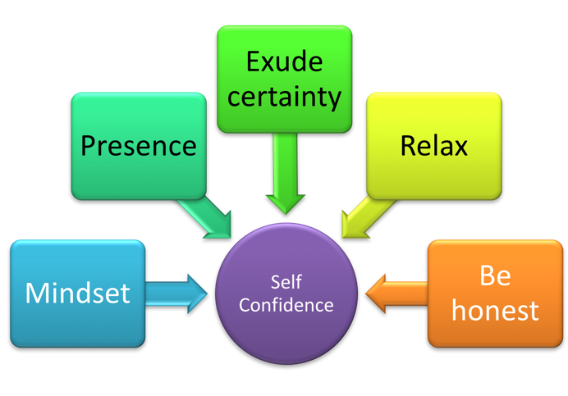 | Communicating Assertively  Use the WISH technique to make an assertive statement:  W = ‘When…’  I = ‘I find…’ or ‘I need…’  S = ‘So I’d like…’  H = “How…  Writing Assertively  - Use strong verbs  - Use short sentences  - Use short paragraphs  - Write in active voice  - State clearly your intent  - Be succinct  Use Your Voice Assertively  - Breathe from your diaphragm.  - Drink plenty of water to stay hydrated; avoid caffeine because of its diuretic effects.  - Posture affects breathing and also tone of voice, so be sure to stand up straight.  - To warm up the tone of your voice - smile.  - If you have a voice that is particularly high or low, exercise it by practicing speaking on a sliding scale. You can also sing to expand the range of your voice.  - Record your voice and listen to the playback.  - Deeper voices are more credible than higher pitched voices. Try speaking in a slightly lower octave.
Listening Assertively  - Base it on the law of reciprocity – if you are interested in me, then I will be interested in you.  - Listening needs to be active. Actively listening shows respect to the other person, even if you don’t agree with what they are saying.  - If you feel you are being listened to, it relaxes you.  - Allow people to complete what they are saying before attempting to respond. Not to do so is disrespectful.  - Make sure you ask clarifying questions during the conversation.  Countering manipulative and bullying behaviour  - Tendency  - You want to please  - You take on more and more work to gain approval  - You find it hard to say ‘no’  - You have a strong desire to think well of others  - You want things to be perfect  - You have a strong need to feel valued  - You tend to discount your own contributions  - Counter behaviour  - Accept that not everyone can be pleased. Remember mutual respect!  - Set yourself sensible limits to balance work and home life  - Be more assertive  - Be more objective - ask others’ opinions  - Realise that perfection isn't possible and erodes confidence  - Learn to value yourself  - Ask if what you are expected to do is fair and reasonable | Build Self-Confidence  - Develop physical confidence  - Use what you already know  - Move beyond perfection  - Adjust your goals to the circumstances  - Stay positive when external factors impact your confidence  - Increase your ability to adapt to change  Ways of saying ‘no’  The Direct 'no'  - When someone asks you to do something you don't want to do, just say ‘no’. The aim is to say no without apologizing. The other person has the problem, but you do not have to allow him or her to pass it on to you.  The Reflecting 'no'  - This technique involves acknowledging the content and feeling of the request, then adding your assertive refusal at the end.  The Reasoned 'no'  - In this technique you give a very brief and genuine reason for why you are saying ‘no’. For example, “I can't have lunch with you because I have a report that needs to be finished by tomorrow.”  The Enquiring 'no'  - This is not a definite ‘no’. It is a way of opening up the request to see if there is another way it could be met. For example, “Is there any other time you’d like to go?”  The Broken Record 'no'  - This can be used in a wide range of situations. You just repeat the simple statement of refusal over and over again. No explanation, just repeat it. It is particularly good for persistent requests.

