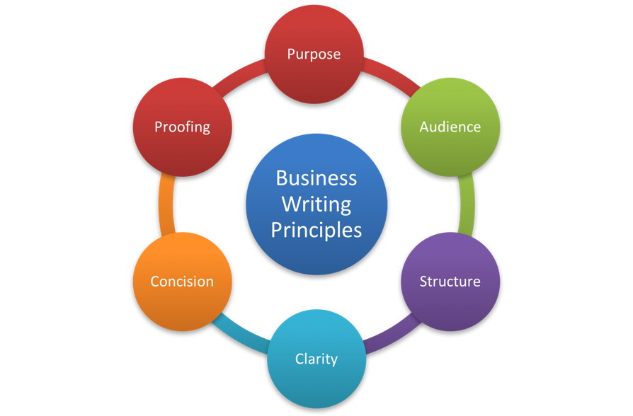
Universal Principles of Good Writing
Consider the audience  - They are giving of their time to read what you have written – so value it  - They may not be subject matter experts – so explain and provide context  - They may not be university professors – so simplify  - They may be seeing the information for the first time – so don’t assume  - They may not get your point – so make it obvious  Achieving Clarity  - The purpose is well defined  - It is concise  - It has structure  - It meets the needs of the audience  - It has been proofed | Questions for a Media Release  - Who? Who are the key players — your company, anyone else involved with the product? Who does your news affect/who does it benefit?  - What? What is new?  - Why? Why is this important news — what does it provide that is different?  - Where? Where is this happening/is there a geographical angle/is the location of business relevant?  - When? What is the timing of this? Does this add significance?  - How? How did this come about?
Being Concise  Start sentences with the subject  This makes it obvious to the reader what your sentence is about.  Use active voice  Passive: The report was written by Mike.  Active: Mike wrote the report.  Use adverbs and adjectives sparingly  In business writing adverbs and adjectives should be used sparingly as they detract from the facts and are based on the opinion of the writer.  Use the shortest form of the word  It is a mistake to think that long words are better. They may inflate the ego of the writer, but they will not impress the reader who is craving understanding. Think of the audience – what words would they prefer to read?  Only explain one idea at a time  Introducing more than one idea will confuse the reader. | Editing  - Structure  - Logical information flow  - The form used complies with workplace requirements  - Headings and formatting guide the reader  - Content  - Has it achieved its purpose?  - Is it complete?  - Is it accurate?  - Is it professional?  - Does it have the right tone?  - Clarity  - Will the audience understand it?  - Is it concise?  - Check sentence length  - Check plain English  - Check redundant words  - Check word choice

Planning your Writing

- Why am I writing? (purpose)
- Is writing the best medium to communicate this message?
- To whom am I writing? (audience)
- What tone will I use?
- When am I writing?
- How am I writing? (which form will be used)
- What effect will my writing have on the reader?
- What do I want to happen? (back to ‘purpose’)

