Make It Stick
Activity Pack

Communication Skills

Helping lessons learned through training become part of how we work.

To the Learner Leader…
This suite of activities has been designed to reinforce the key learning from the Communication Skills course. They have been designed to be led by team leaders or designated trainers and do not require training experience, though for best results we recommend that whoever is leading the activities understands the principles of adult learning and has some experience in leading learning activities.
This suite of activities will provide you with up to six months of learning reinforcement. We recommend that an activity is run each month following the Communication Skills course.
When running each activity:
- Ask the group to reflect back on the original course they attended:
- What takeaways did they have?
- What have they tried to implement?
- When revisiting some of these activities for a second time, ask them what additional ideas or thoughts they have in applying the concepts and tools in the activities to their job.

Each activity will take 10-15 minutes to run depending on the size of the group.
There is one activity to a page. Each activity has a brief introduction followed by instructions for the trainer.
We suggest the following to optimise your learning experience:
- Have the group meet away from their normal workspace
- Make sure mobile devices are switched off so that everyone fully engages
- Make the environment ‘safe’ and encourage everyone to contribute
- Run these activities with everyone standing – try running these outdoors in the fresh air
- Have other team members take the lead and run an activity – this will build confidence and leadership skills
- Don’t be afraid to improvise – the learning needs to be about you and your group so make it meaningful
- When debriefing an activity get the group to reflect on what the activity means for them, and what they will do differently or continue to do that underscores the learning points from the activity
Activities in this pack
- Adjusting your communication approach
- Utilising pitch, tone and speed
- Using the STAR method
- Making inferences
- Barriers to active listening
- Insights through questioning

Activity 1: Adjusting your communication approach
Introduction
The REACH profile is a tool that can be utilised time and again to help us understand and communicate with people with different personal styles.
Instructions
Ask each of your team to think of a recent ‘challenging’ instance of communication (or miscommunication) between themselves and a colleague, customer or supplier. This could be verbal or in writing. It could be that they missed the point, they asked for things to be repeated several times, they interrupted, or they responded in a way that wasn’t expected or showed they didn’t understand.
Get them to circle where they sit on the REACH grid and where they think the other person sits on the grid.
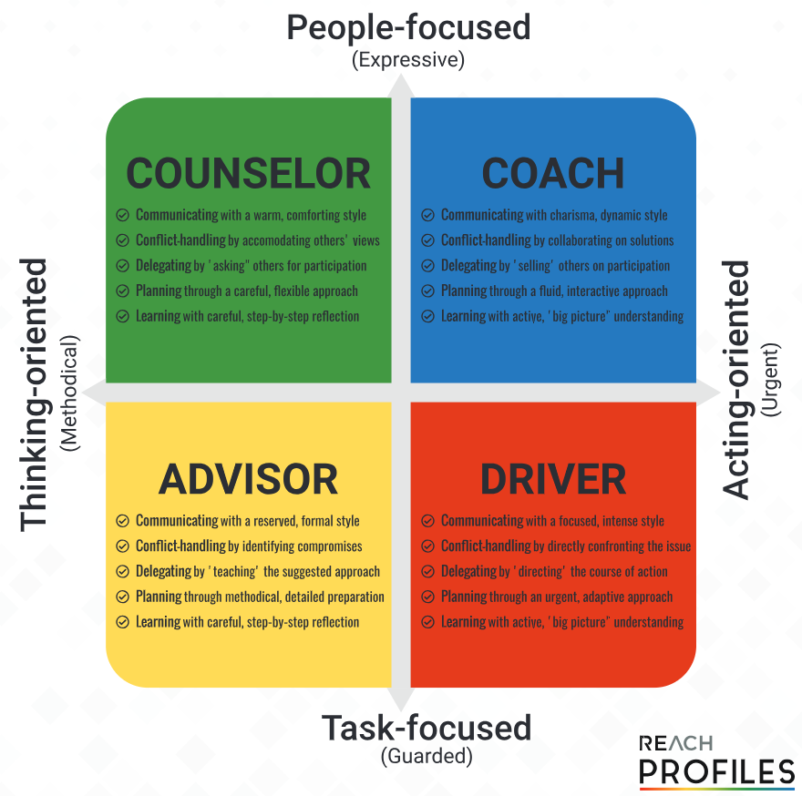
Ask them to reflect on the approach they took:
- Was it the best approach considering the circumstance?
- Was it the best approach considering the personal style of the other person?
- What could they have done differently?
Activity 2: Utilising pitch, tone and speed
Introduction
When communicating with impact, try the following:
- Vary the pitch of your voice between high and low
- Vary the pace at which you speak – not too fast, not too slow, be natural
- Tone refers to the mood you create through pitch, pace, stressing particular words, pausing and word choice
Instructions
- Ask your team what they need to do to communicate with impact. In the discussion include the three points mentioned above.
- Get your team members one at a time to read one of the excerpts below to communicate with impact. Alternatively choose your own speech excerpt or part of a speech made by a senior leader within your organisation.
- Have the rest of the team give feedback on what they thought of the delivery – what emotional response did they have; was it clear what the message was; did the pitch, speed and tone hit the mark; what worked well; where could improvement be made?
Part of a speech by Nora Ephron
‘Whatever you choose, however many roads you travel, I hope that you choose not to be a lady. I hope you will find some way to break the rules and make a little trouble out there. And I also hope that you will choose to make some of that trouble on behalf of women.’
Part of a speech by Winston Churchill
‘We shall go on to the end, we shall fight in France, we shall fight on the seas and oceans, we shall fight with growing confidence and growing strength in the air, we shall defend our island, whatever the cost may be, we shall fight on the beaches, we shall fight on the landing grounds, we shall fight in the fields and in the streets, we shall fight in the hills; we shall never surrender’
Part of a speech by Greta Thunberg (15 years old)
‘In the year 2078, I will celebrate my 75th birthday. If I have children maybe they will spend that day with me. Maybe they will ask me about you. Maybe they will ask why you didn't do anything while there still was time to act. You say you love your children above all else, and yet you are stealing their future in front of their very eyes. Until you start focusing on what needs to be done rather than what is politically possible, there is no hope.’
Part of a speech by Dr Martin Luther King, Jr.
‘I say to you today, my friends, so even though we face the difficulties of today and tomorrow, I still have a dream. It is a dream deeply rooted in the American dream. I have a dream that one day this nation will rise up and live out the true meaning of its creed: “We hold these truths to be self-evident: that all men are created equal.” I have a dream that one day on the red hills of Georgia the sons of former slaves and the sons of former slave owners will be able to sit down together at the table of brotherhood.’
Activity 3: Using the STAR method
Introduction
The STAR method provides a quick and simple check to see that what is being communicated is clear, complete, correct and concise.
S = Situation - First, state what the situation is. Try to make this no longer than one sentence. If you are having trouble, ask yourself, “Where?”, “Who?” and “When?”
Example: “On Tuesday, I was in a director’s meeting at the main plant.”
T = Task - Next, briefly state what your task was. Again, this should be no longer than one sentence. Use the question, “What?” to frame your sentence, and add the “Why?” if appropriate.
Example: “I was asked to present last year’s sales figures to the group.”
A = Action - Now, state what you did to resolve the problem in one sentence. Use the question, “How?” to frame this part of the statement.
Example: “I pulled out my laptop, fired up PowerPoint, and presented my slide show.”
R = Result - Last, state what the result was. This will often use a combination of the six roots.
Example: “Everyone was wowed by my prep work, and by our great figures!”
Instructions
Have each of your team members practice using the STAR method. Ask them to think of a situation where they need to deliver a clear communication to a colleague, customer or supplier. The situation can be anything relevant. Some examples are listed here:
- Compliment a colleague on a job well done
- Ask a colleague to assist on a task
- Explain to a colleague what action they took
- Provide advice to a customer or supplier
Ask the rest of the team to mentally check that each part of the STAR method was used and to provide feedback.

Activity 4: Making inferences
Introduction
Inference is the practice of assigning assumptions, conclusions and beliefs to what you observe. At times, if we apply the wrong reasoning the assumptions, conclusions and beliefs and ultimately our response to these can be faulty. Correct inference means asking the right questions to gain objectivity and accuracy:
- Is this the right conclusion?
- Why am I making these assumptions?
- Why do I think this is the right thing to do?
- Is this really based on all the facts?
- Why does he/she believe that?
- Is your reasoning based on facts and logic?
Instructions
Use an example from your own experience to demonstrate how the ladder of inference works and can lead to the wrong actions being taken.
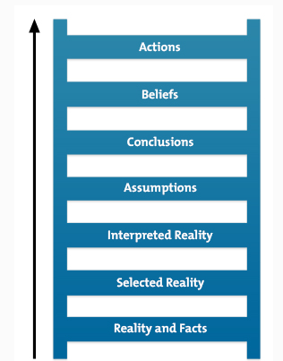
Ask your team members to recall something they have observed at work and thought one thing only to discover that their reading of the situation was very different to the facts. Unpack the reasoning to test each stage of the ladder of inference – best done in reverse:
- I took this action because I believed this
- …and I believed this because I concluded this
- …and I concluded this because I assumed this
- …and I assumed this because of how I interpreted this
- …and I interpreted this based on the following facts
Use the example from your team member to try to unpick where the reasoning went awry.
Activity 5: Barriers to active listening
Introduction
Active listening requires conscious effort on behalf of the listener. There are a number of barriers that the listener can erect, often unconsciously, that inhibit the speaker. Being aware of these barriers will help make for more effective listening.
Instructions
Ask your team to name the common barriers to effective listening and how to avoid them.
Common Barrier to Listening | Strategy to Overcome Barrier
Knowing the Answer – Jumping to conclusions as to where the speaker is headed. Becoming close-minded to what is being said. | Let the speaker finish and wait 3 seconds before responding. Make the commitment to learn at least one unexpected, worthwhile thing during every conversation.
Trying to be Helpful – If you as the listener step in and offer a solution, you’re implying that you’re more capable of seeing the solution than the speaker is. | Ask if they would like your input to assist with determining a solution. The best advice you can give is only from the experiences you have experienced.
Treating Discussion as a Competition – Feeling compelled to challenge every point the speaker makes. Greatly inhibits the listener from stretching and seeing a different point of view. | Avoid dismissing their statements completely. Instead affirm points of agreement. Be clear in communication with what you do agree with and what you don’t agree with.
Trying to Influence or Impress – A person who has an agenda other than simply to understand what the speaker is thinking and feeling will not be able to pay complete attention while listening. | Make note of your internal motives while you’re listening. As you notice your motives in more detail, you’ll eventually become more conscious of your ulterior motives, allowing you to let go and listen.
Reacting to Red Flag Words – Red flag words or expressions trigger an unexpectedly strong association in the listener’s mind, often because of the listener’s private beliefs or experiences. | When you hear a red flag word, ask the speaker to clarify immediately as to their meaning of the word.
Believing in Language – It is an assumption that words that are clear to one person are clear to another. Individual experiences help interpret words. The speaker’s experience may be different to the listener’s experience. | Don’t assume the words or expressions mean the same to you as they do to the speaker. Ask the speaker supporting questions to verify what the words mean to them.
Missing the Forest for the Trees – A common saying is to ‘miss the forest for the trees’. Sometimes we pay such close attention to the detail that we miss the overall meaning of context of a situation. | Encourage the speaker to supply missing context or examples by asking them open-ended questions.
Over-splitting or Over-lumping – Some speakers (splitters) pay more attention to how things are different. Others (lumpers) tend to look for how things are alike. | An approach to overcoming this barrier when listening is to ask questions to determine more precisely where you agree or disagree with what the speaker is saying, and then to explicitly point that out (when appropriate).
Activity 6: Insights through questioning
Introduction
Good questioning skills are another building block of successful communication. Questions help us gather information, clarify facts and communicate with others. The main types of questions are:
Open questions – How, what, where, why, when, who
Closed questions – Is, do, are, will, have, were (yes/no response)
Instructions
Ask one of your team to think of a task they have recently completed at work. The rest of the team then asks only open questions to that team member to try and determine what the task is. They may not ask any direct questions such as “What is the task?” If anyone asks a closed question the person can decline to answer.
After five minutes change the rules of the game.
Another staff member thinks of another workplace task or workplace object. This time the remaining team members are to ask only closed questions to identify the task or object.

Debrief questions for your team:
- Did you experience a recent exchange where you were frustrated by not getting the answers you were wanting? Why was this? Did it have anything to do with the types of questions you were asking?
- Did you experience a recent exchange where you found it very easy to gain the information you were seeking? What bearing did the questions you were asking have on this result?
- Apart from asking the right questions, what else must you pay attention to when communicating?
  - Listening
  - Body language
  - Word choice
  - Voice qualities

