Understanding your Response to Conflict  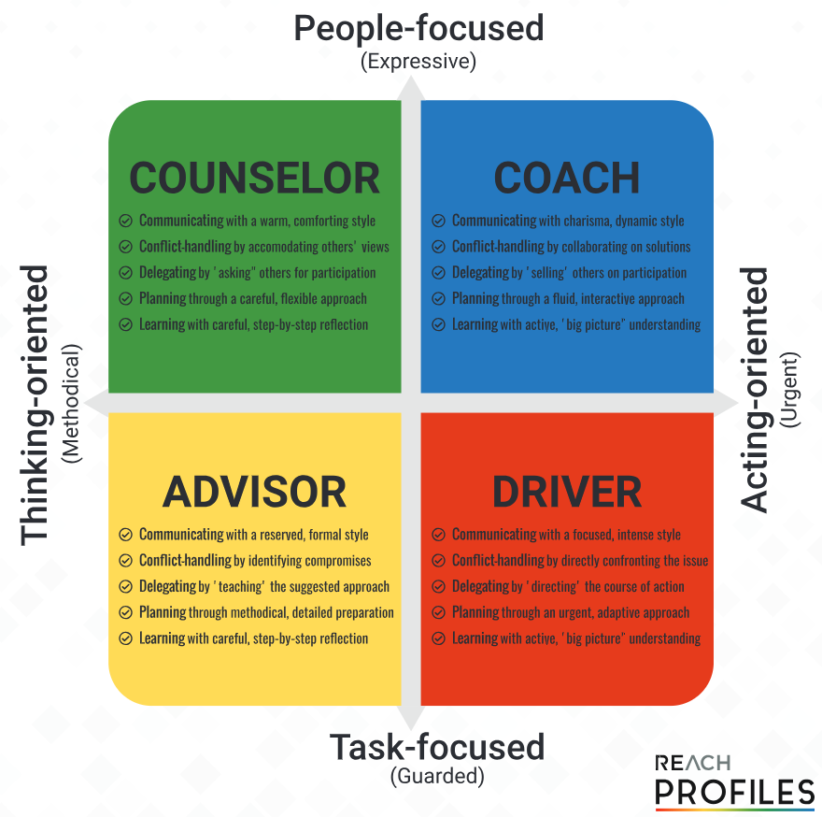  Your personality traits can also mean that you are predisposed to how you handle conflict:  Counselor – accommodates others’ views when handling conflict  Coach – collaborates on solutions to conflict when handling conflict  Advisor – identifies compromises when handling conflict  Driver – directly confronts the issue when handling conflict  This describes your ‘default’ position on how you like to deal with conflict.  The Thomas-Kilmann Conflict Mode Instrument (TKI) – Conflict Styles  8 Common causes of Conflict  A manager can contribute to conflict through: | Competing  - is assertive and uncooperative  - pursues his/her own concerns at the other person's expense  - uses whatever power seems appropriate to win your own position—your ability to argue, your rank, or economic sanctions.  - means "standing up for your rights" or simply trying to win  Accommodating  - unassertive and cooperative  - neglects his/her own concerns to satisfy the concerns of the other person  - there is an element of self-sacrifice in this mode  - might take the form of selfless generosity or charity  - will yield to another's point of view  Avoiding  - is unassertive and uncooperative  - neither pursues his/her own concerns nor those of the other individual  - might take the form of diplomatically sidestepping an issue or postponing an issue until a better time  - likely to withdraw from a threatening situation  Collaborating  - is both assertive and cooperative  - involves an attempt to work with others to find some solution that fully satisfies their concerns  - means digging into an issue to pinpoint the underlying needs  - might take the form of exploring a disagreement to learn from each other's insights or trying to find a creative solution to an interpersonal problem  Compromising  - is moderate in both assertiveness and cooperativeness  - looks for an expedient, mutually acceptable solution that partially satisfies both parties  - falls intermediate between competing and accommodating  Resolving Conflict  Running a Mediation Meeting  Remain Neutral  Your role as a facilitator is to remain neutral, to ensure the discussion flows and that all parties are able to express themselves, and to guide the discussion to an agreement. If you have been less than neutral, then the longevity of any agreement may be in doubt.  Explain the ground rules for all parties  - Respectful communication  - Willingness to listen  - Willingness to share  - Courteous and well-mannered to all parties  - Openness to new ideas  Actively Listen  - Display open body language  - Lean forward to demonstrate interest  - Beware of folding your arms or assuming a judgemental posture  - Take brief notes to aid your memory when summarising  Summarising and Reflecting  This is your chance to restate what people are feeling in a way that focuses on the facts of the matter. If you are not used to these conversations, the language skills involved can take some practice. Try to vary your language so that it does not distract the listener.

