What is a strength?  A pre-existing capacity for a particular way of behaving, thinking or feeling, that is authentic and energising to the user, and enables optimal functioning, development and performance.  The benefits to playing to the  strengths of a team  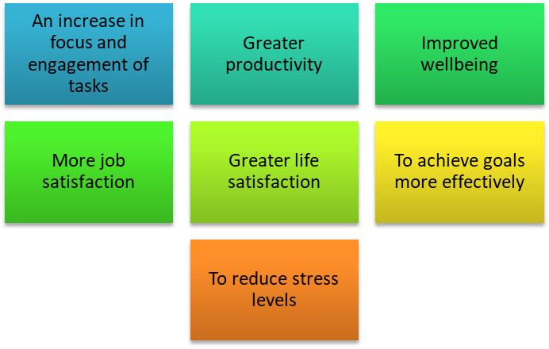  How do you utilise the strengths of your team:  - Do I understand what their strengths are?  - What opportunities can I provide for their strengths to shine?  - How can I observe their strengths in action?  - How can I encourage the use of their strengths? | Creating a culture of gratitude  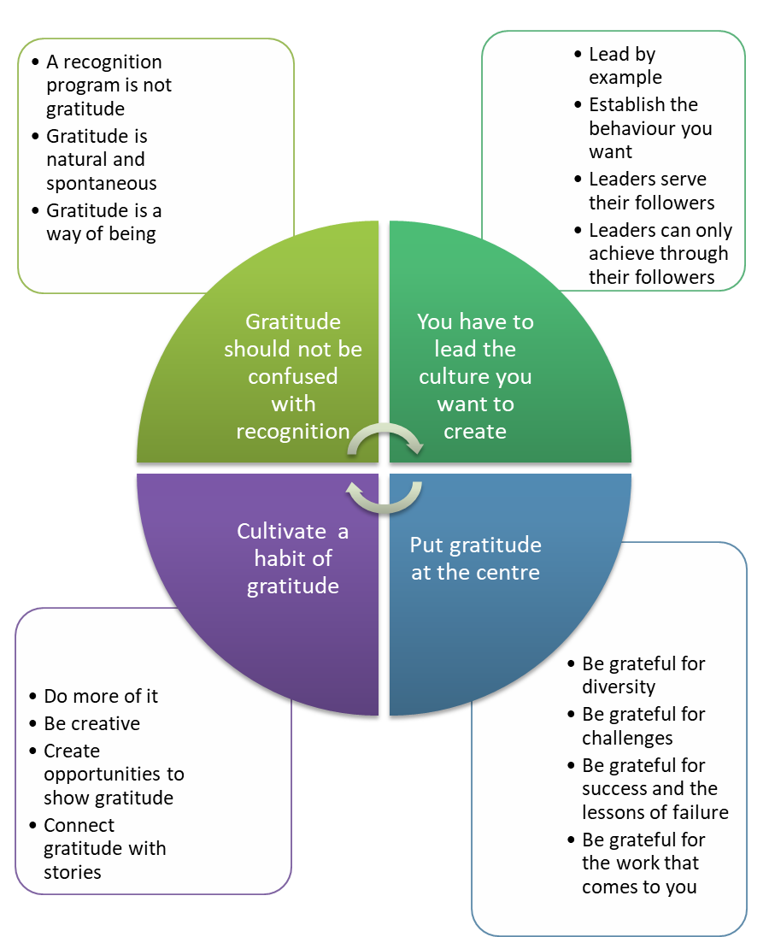  Cultivate a personal habit of gratitude  Write down things that you’re grateful for today and reflect upon the reason why.  Thank a person who regularly delivers a service to you and tell them why what they do is important to you.  Write a gratitude letter to someone who has had a positive influence in your life and tell them why you appreciate them.  Accept compliments gracefully and thank the person for making the comment rather than brushing it off or dismissing it.  Keep a gratitude journal and record the things that you are grateful for each day. Read through it from time to time.  If someone gives you good service, send an email to their manager praising them as well as giving a personal thank you.  Make a list of the ‘invisible’ people who make your life better: the emergency services, refuse collectors, farmers, service providers. Imagine life without them.

You and your customer  The intersection in the diagram below represents the contact and the contract between you and a customer. The customer might be someone internal to your organisation or someone who purchases or accesses the goods and services your organisation supplies.  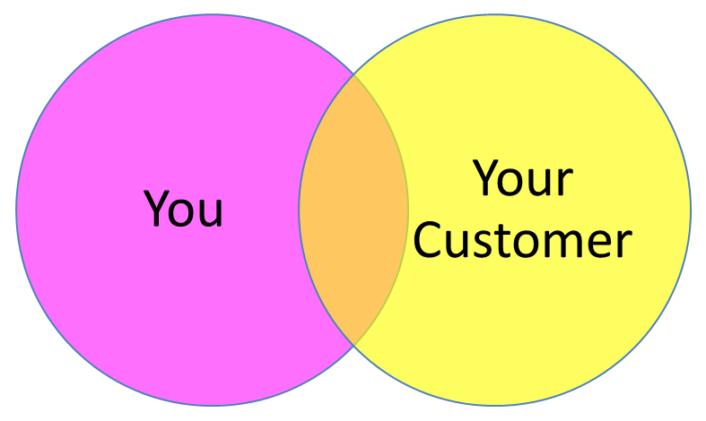  Customer Empathy Map  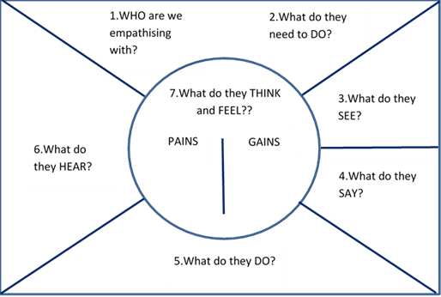 | Questions for the Empathy Map  1. WHO are we empathising with?  - Who is the person we want to understand?  - What is the situation they are in?  - What is their role in the situation?  2. What do they need to DO?  - What do they need to do differently?  - What jobs do they want or need to get done?  - What decisions do they need to make?  - How will we know they were successful?  3. What do they SEE?  - What do they see in the marketplace?  - What do they see in their immediate environment?  - What do they see others saying and doing?  - What are they watching and reading?  4. What do they SAY?  - What have we heard them say?  - What can we imagine them saying?  5. What do they DO?  - What do they do today?  - What behavior have we observed?  - What can we imagine them doing?  6. What do they HEAR?  - What are they hearing others say?  - What are they hearing from friends?  - What are they hearing from colleagues?  - What are they hearing second-hand?  7. What do they THINK and FEEL?  - What are their PAINS – fears, frustrations and anxieties?  - What are their GAINS – wants, needs, hopes and dreams?

