Effective Communicator Needs  - Knowledge  - Skills  - Attitude  “People will forget what you said. They will forget what you did. But they will never forget how you made them feel.”- Maya Angelou  Seven Deadly Sins  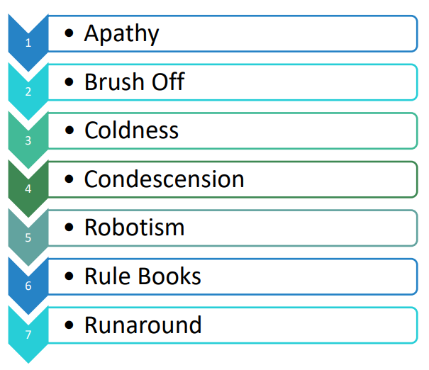  The ABCDE (Five Qualities) of a Good Telephone Voice  - Alertness - Your voice must have spark and energy.  - Balanced - Your voice should be soft, happy, in a pleasant mood.  - Conversational tone – Be a human being talking with (not at) another human being.  - Distinctness – Clearly articulate each word and show that you are seeking understanding.  - Expressiveness – Vary the tone and pace of your voice to suit the situation. | Your Welcome Should HAIL  Use the HAIL technique to allow your listeners to hear and digest what you are saying.  H = Honesty (straight and clear)  A = Authenticity (be yourself)  I = Integrity (be trustworthy)  L = Love (wish people well)  The 6 P’s to Paraverbal Communication  Practice voice modulation to help you get the right speed, tone and clarity in your speech.  P = Pace (how fast/slow)  P = Projection (how loud/soft)  P = Pitch (how high/low)  P = Pause (convey shades of meaning)  P = Pronunciation (articulate each word fully)  P = Positivity (wear a smile at all times)  Create a Positive First Impression  - Answer promptly – before the third ring.  - Be prepared – stop what you are doing, smile, take a breath and focus.  - Introduce yourself.  - Use their name as soon as possible.  - Use the 6 P’s to paraverbal communication.  - Be an ‘active’ listener.  - Know when to ask for help – remember you don’t need to know everything. You just need to know who can help.  - Thank them for calling. Breathe from your diaphragm.
4 Key Parts to Your Phone Greeting  - Salutation  - Company Name  - Your Name  - Offer of Assistance  E.g., “Good morning, PD Training, this is Stacey -how can I assist you today?”  Show Urgency  Everyone is busy and wants things done immediately. Let your caller know you will manage their enquiry with a sense of urgency.  - Express Urgency – rest assured that this will be done  - Quote facts for postponement of resolution  - Promise results soon  - Apologize for the inconvenience  - Keep the customer informed about the proceedings  Use a phrase like:  “Apologies there has been a delay. Let me investigate right now for you and determine what we can do.”  Ending a Call Politely and Professionally  - End the call on a high note – make them feel welcomed to call you again.  - Summarise – ‘Before you go, let me summarise…'  - Add Value – ‘One tip I love to provide…’  - Thank the client for calling – it is essential to make the client feel cherished and important.  - Wafflers – switch to the past tense. E.g., ‘I appreciate the time you have spent in explaining the situation to me.’ | Good Questioning  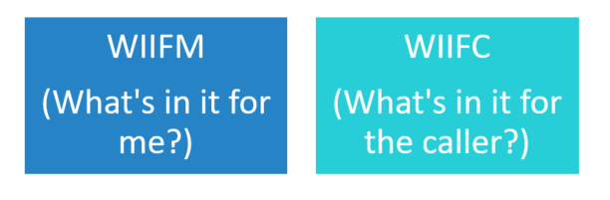  Techniques  - Open Questions help you:  - Achieve an elaborate answer  - Receive an explanation or clarification  - Get the respondent to think and reflect  - To receive opinions and answers  - Give the respondent control  E.g., What, how, why, where?  - Closed Questions are used when you want:  - To receive/confirm facts  - A quick answer  - To keep control of conversation  - A one-word response  - To keep it easy for the respondent as they don’t need to reveal too much  E.g., Do, are, Have, Can Should?  - Clarifying Questions – e.g., “And you need an answer by Friday?”  - Seek Satisfaction/Understanding – e.g., “Are you okay with the suggestion I made?”  Use the HEAT to Defuse an Irate Client  H = Hear them out  E = Empathize  A = Ask questions  T = Take responsibility and thank them

