Make It Stick
Activity Pack

Supervising Others

Helping lessons learned through training become part of how we work.

To the Learner Leader…
This suite of activities has been designed to reinforce the key learning from the Supervising Others course. They have been designed to be led by team leaders or designated trainers and do not require training experience, though for best results we recommend that whoever is leading the activities understands the principles of adult learning and has some experience in leading learning activities.
The suite of activities will provide you with up to six months of learning reinforcement. We recommend that an activity is run each month following the Supervising Others course.
When running each activity:
- Ask the group to reflect back on the original course they attended:
  - What takeaways did they have?
  - What have they tried to implement?
  - When revisiting some of these activities for a second time, ask them what additional ideas or thoughts they have in applying the concepts and tools in the activities to their job.

Each activity will take 10-15 minutes to run depending on the size of the group.
There is one activity to a page. Each activity has a brief introduction followed by instructions for the learner leader.
We suggest the following to optimise your learning experience:
- Have the group meet away from their normal workspace
- Make sure mobile devices are switched off so that everyone fully engages
- Make the environment ‘safe’ and encourage everyone to contribute
- Run these activities with everyone standing – try running them outdoors in the fresh air
- Have other team members take the lead and run an activity – this will build confidence and leadership skills
- Don’t be afraid to improvise – the learning needs to be about you and your group so make it meaningful
- When debriefing an activity get the group to reflect on what the activity means for them and what they will do differently or continue to do that underscores the learning points from the activity
Activities in this pack
- Adapting your communication style
- Setting clear expectations
- Troubleshooting delegation
- Providing balanced feedback
- Where is my team headed?
- Resolving conflict

Activity 1: Adapting your communication style
Introduction
The REACH profile is a tool that can be utilised to understand how people prefer to communicate and what adjustments someone can make to communicate to greater effect.
Instructions
Ask each of your team to think of a recent ‘challenging’ communication between themselves and a colleague or customer or supplier. This could be verbal or in writing. It could be that they missed the point, they asked for things to be repeated several times, they interrupted, or they responded in a way that wasn’t expect or showed they didn’t understand.
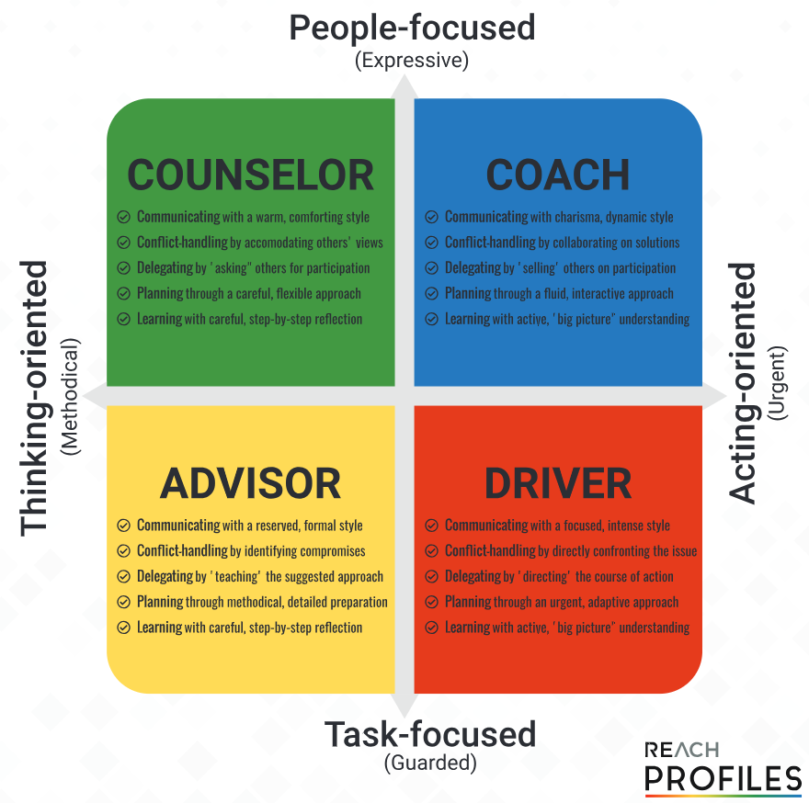
Get them to circle where they sit on the REACH grid and where they think the other person sits on the grid.

Ask your team member to reflect on the following questions and share their reflections with the rest of the group:
- Was my approach the best for the personality type I was communicating with?
- When they responded in a way I didn’t expect, could I have been more aware that it is just their style and simply adjusted or adapted, instead of letting my reaction and emotions spiral?
- Reflecting on the situation, what could I have changed in how I was communicating?
Invite the rest of the group to provide input into what they would have done in similar circumstances.

Activity 2: Setting clear expectations on tasks
Introduction
One of the critical skills of supervisors is displaying clarity. Without clarity, direct reports will struggle to understand what it is they are required to do and for what purpose they are doing it. A useful framework for communicating the requirements of tasks is the 5W + H model:
1W - What are the key components to their role or task?
2W - What steps are involved?
3W - What should the end result look like?
H - How does their role or this task tie into organisational goals?
4W - Who will the employee need to talk to?
5W - When should the employee check in?
Instructions
The 5W + H model can be applied to tasks or job roles. Ask each of the group to identify a team member and to then use the model to apply it to a job role or a task that this team member will complete. This is best done by writing out the script on a piece of paper.
Now split the group into pairs and have each pair recount their ‘5W + H’ script.
The person hearing the script is to critically evaluate what is being said and to give feedback on anything they are unclear about. The person reading the script is to take note of the feedback, adjust their script and then read out the new script. This will continue until the script is ‘crystal clear’ i.e., it contains all the elements required and the person hearing the script is in no doubt about what to do and why they are doing it.
Complete in pairs, then swap roles and repeat.

Activity 3: Troubleshooting Delegation
Introduction
Effective delegation saves money and time, develops people and teams, grooms successors and motivates people. Poor delegation causes frustration, demotivates and confuses people and teams. Supervisors need to read the signs of when delegation is ineffective or has failed so that the situations can be rescued.
Instructions
For each of the warning signs in the table below, get the group to ponder what each sign means and what they could do to respond.
Warning Sign | What you can do to respond
The delegate keeps coming to you with questions | - Although the delegate should feel comfortable coming to you and asking questions, there can come a point where they are relying on you too much.  - One way to reduce the need for your time, and to increase their independence, is to show them where they can find the answers.  - Another approach is to ask them for recommendations when they have a problem. Then, help them explore the possibilities and choose a solution.  - It may also be possible that you have assigned a complicated task to someone who is not prepared for it. If this becomes the case, the best approach is usually to ask a senior person to assist the junior person with the task. (Once again, this helps develop employees and increases their independence.) Try to avoid re-assigning a task unless it’s necessary.
You hear that another team member is performing the task | - It’s always best to get your information from the source. Talk to the delegate and find out who they are using as a resource and how much of that person’s time is being used. If you feel that too much of that person’s time is being used, suggest alternate resources.  - You may also want to check with the person involved in the task to ensure they don’t feel overwhelmed or taken advantage of.  - In general, when you hear these kinds of rumours, keep a close eye on the situation, and react appropriately.
The result is not what you expected | - First, take a moment to evaluate the problem. Is it done incorrectly, or just not done the way you would have done it? (There is a difference between the two!)  - Explain to the delegate what is done incorrectly and how it can be resolved. Take time to find out why the delegate did the task the way they did. Were the original instructions incorrect? Were they unable to find help when they needed it? Did someone else tell them to do it differently? Take careful notes during this discussion. This can provide valuable lessons for you and the delegate.

Now have an open discussion with the group on what other issues they have encountered when delegating work and ask the group to provide feedback and suggestions for dealing with each issue.

Activity 4: Providing balanced feedback
Introduction
Balanced feedback involves commending things done well as well as identifying and recommending changes while ensuring that important feedback messages are understood and acted on. Balanced feedback stops people feeling de-motivated by feedback they may find challenging. It is important to check with the team member that they are aware of both what they are doing well and where they need to improve and not to let the improvement focus be lost amongst the commendations. A model to use when giving feedback is:
Commend | I appreciate the time you spent on…  In general, I am happy with your performance. I have been impressed with the way you have…
Recommend | One area where I’d like to see an improvement is…  Perhaps next time around you could also…  It’s not yet meeting my expectations. What I’d like to see is…  One way of developing your skills even further would be to…
Commend | I feel confident that once you implement the strategy/ies that we have been working on, it will go better next time.  I appreciate your willingness to take on board feedback.
Then follow up with:
So, tell me what you are doing well?
Now, tell me what else you need to do?
Instructions
Split the group into pairs. Each person is to think of some feedback they wish to deliver which could be modelled on feedback they recently delivered to a team member or are planning to do so. Allow a couple of minutes for each person to plan what they are going to say using the Commend – Recommend – Commend model then have them deliver the feedback. The other person is to listen and respond when the first person asks:
So, tell me what you are doing well?
Now, tell me what needs to change?
Then swap and repeat so that both people have the opportunity to deliver their feedback.
++++++++++
As a group discuss why sometimes we may be reluctant to give feedback. This can include:
- Not knowing how the other person will respond
- Fearing repercussion especially if giving feedback to a more senior person
- Feeling awkward and vulnerable
- Not being confident of saying the right thing or using the right words
- Not wanting to damage the relationship
Ask how can we get past this fear or reluctance?

Activity 5: Where is my team headed?
Introduction
Tuckman's model (1965) describes four stages of team development. These stages are not always distinct but often merge into each other. Teams may move back and forth between them as new members join, new challenges emerge, or changes are introduced. As a supervisor having an awareness of which stage your team is at will allow you to change your approach. Here is a brief description of each stage.
Stage 1 – Forming | Stage 2 - Storming | Stage 3 - Norming | Stage 4 - Performing
This stage is usually characterised by uncertainty regarding team member roles and the operation of the team itself. | The second stage consists of establishing a clearer understanding of the team's expected outcomes and the roles team members play to achieve those outcomes. | The norming stage of the team evolution process comes about as members become involved in working out basic operational ground rules within the group. | By this stage most of the initial problems and issues will have been overcome through a process of negotiation by the team members involved.

Instructions
As a group discuss each of the following scenarios and decide which stage the team is at and what actions the supervisor can take to move the team forward.
Scenario 1
Your team has embarked on a weekend retreat at a resort just outside the city. On the second day, over half of the participants do not show up at a morning meeting. You hear that they were at the resort bar late the evening before.
Scenario 2
At your first staff meeting, everyone is very quiet. No one will answer questions, offer ideas or provide information.
Scenario 3
Your team has been working together for about six weeks. At a staff meeting, two members disagree about the approach for a certain task. The argument becomes very heated.
Scenario 4
Your team has been working together for about six months. In recent meetings, you feel invisible – they don’t seem to need you around anymore and are functioning on their own.

Activity 6: Resolving Conflict
Introduction
Resolving conflict between team members is part of the skills required by supervisors. Using a process and a tool will improve the chance of successful resolution. A useful technique is OPEN:
O | On the Table
 | Identify positions, perceptions, interests, needs, concerns, goals, motivations...
P | Put the Problem into Focus
 | What is the problem? What is not the problem?
 | Make sure you identify the real root cause. Problems are often not what they seem!
E | Explore Your Options
 | Brainstorm solutions. The objective here is quantity, not quality.
 | Once you have some solutions, evaluate and come up with a short list.
N | Negotiate a Solution
 | Always aim for win-win.

Instructions
Role play the following scenarios using the process above with:
- One person playing the role of ‘Supervisor’
- Two other people being team members in conflict
The ‘Supervisor’ is to:
- Ask each party to identify their position
- Clarify exactly what is and is not the problem – so that both parties can agree
- Brainstorm solutions with both parties – how can the problem be solved?
- Negotiate a solution
Scenarios (or make up your own):
When the supervisor’s carpark is free, Ramon seems to mostly get use of it, which Heather finds unfair.
Mike asks Joan for help responding to a customer inquiry, but Joan refuses to lend a hand because she is working on a tight deadline and doesn't want to waste time. There has been tension between the two ever since, and now Joan needs Mike’s help on a project, but Mike is not being very responsive.
Matilda got a promotion that her friend Kevin was also going for. Now things are awkward between the two. Matilda wants to keep the friendship going, but Kevin isn’t even speaking to her outside of team meetings.

