Promoted Within the Team  Do:  - Take actions that demonstrate your credibility  - Make clear that you value any disappointed competitors and that you will support them going forward  - Ask former peers for honest feedback  Don’t:  - Start any mayor overhauls right away  - Maintain close, personal relationships with former peers  - Forget to connect with your new peers and your new boss  Set Expectations  Be clear on the Company Vision.  Understand your Department’s Vision and how it fits into the Company Vision.  What are your team goals to achieve these visions?  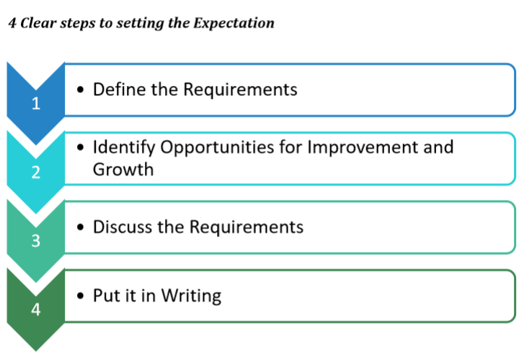 | Set your Expectations with SMARTER Goals  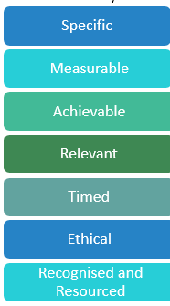  10 Rules for Successful Delegation  - Determine what can be delegated  - Pick the right person  - Explain why you’re delegating  - Be specific, Be SMARTER  - Set them up for success  - Touch base  - Don’t micromanage  - Offer feedback/ask for feedback  - Say thanks – be patient  - Don’t over-delegate  5 Top Tips to prepare yourself to provide feedback  - Appropriate time and place  - In person feedback  - Be prepared  - Confirm recipient is focused on listening  - Determine what can be delegated
3 Stages to Receiving Feedback  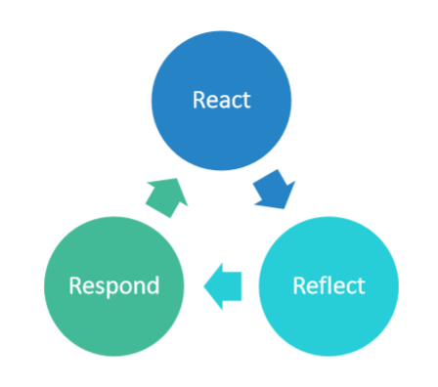  Feedback Delivery Tools  - Primacy/Recency Effect  - Open-faced sandwich or commend-recommend-commend  - Direct Praise or Criticism  - 360 degrees  Deliver Difficult Feedback with the SBI Model  When delivering feedback, deliver it from the “I” perspective.  Situation – where or when  Behaviour – what I saw or heard  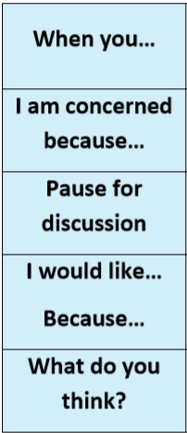  Impact – what this leads to, the result or the outcome | Manage your Time  80/20 rule (Pareto’s Principle) – 80% of your results come from only 20% of your actions  Urgent-Important Matrix – Covey  Important – these are activities that lead to achieving your goals and have the greatest impact on your life  Urgent – these activities demand immediate attention but are often associated with someone else’s goals rather than your own  Block out times around your energy cycle – schedule your important work during your peak energy  Team Development Stages  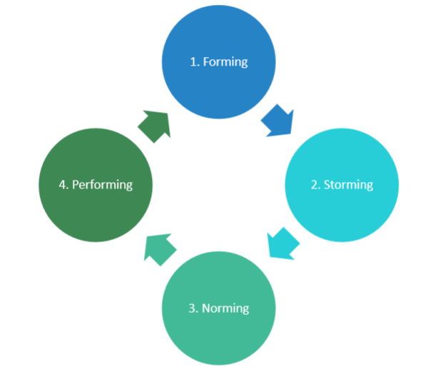  - Forming – Style of Leadership required – Telling  - Storming – Style of Leadership required – Selling  - Norming – Style of Leadership required – Consulting  - Performing – Style of Leadership required – Delegating

