5 Achieving Dimensions  - Risk tolerance  - Intensity  - Adaptability  - Assertiveness  - Decision making  5 Relating Dimensions  - Affiliation  - Consideration  - Openness  - Status Motivation  - Self-protection | Kotter’s change model
Projecting Self-Confidence  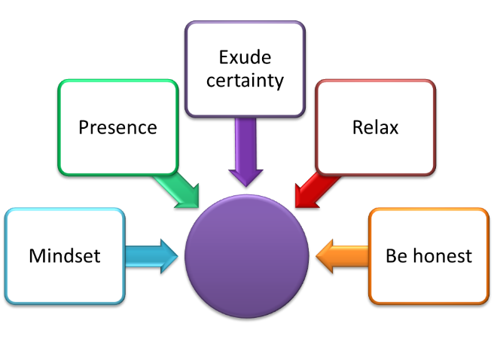 | Problem Solving Model
Building Collaborative Teams  - Make visible investments  - Mentor and coach  - Support a sense of community  - Build on heritage relationships  - Assign team members who are both task and relationship oriented  - Build necessary soft skills  - Model collaborative behaviour  - Understand role clarity and task ambiguity | Conjuring up the courage to act  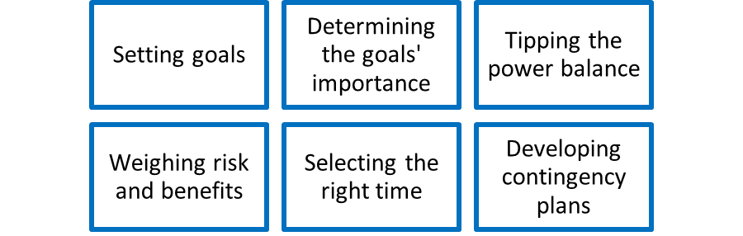
Positive and Negative influence  Influence can be thought of as positive or negative. Positive influence is influence that is applied transparently and with integrity where the goal is to benefit the person being influenced. Negative influence can also be called manipulation which lacks transparency and where the goal is to benefit the influencer. | Three strands of empathy  - Cognitive empathy is understanding how people think about things – what views they hold.  - Emotional empathy is understanding how people feel.  - Compassionate empathy is when you understand how someone feels and you desire to help them deal with those feelings and the situations that are causing those feelings.
Handling emotions | Openness
Motivation and Engagement
