My Personality and Time Management  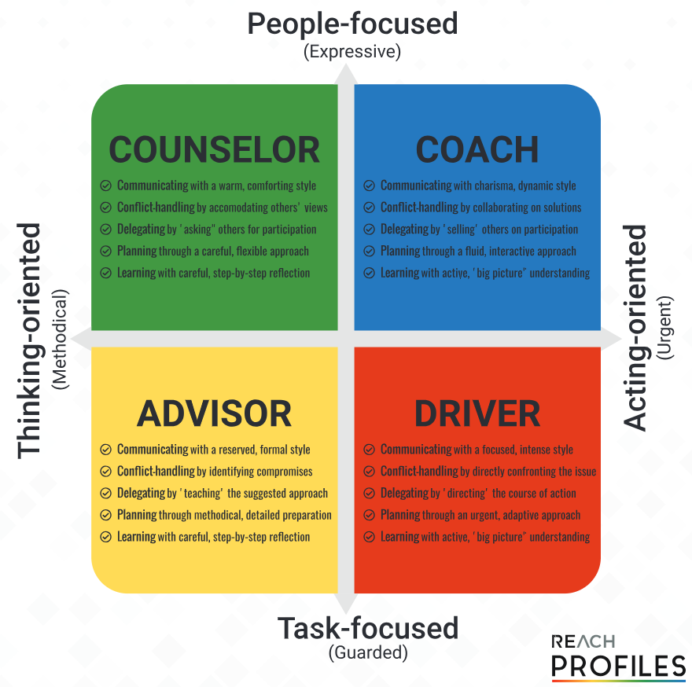  Counselor  - Impact on people  - Need more detail and time to think  - Would like to see mention of people for their efforts  - Would like to share the accountability of the task  - Will want to read or know the instructions in detail  Coach  - Likes a story  - People focussed  - Team driven, and outcome focussed  - Likes not to be allocated and held accountable to tasks  Driver  - Dot points  - Sentences not necessary  - Outcome driven  - Don’t give me the detail  - Action to take  - Expect them immediately  - Will skim read for action  Advisor  - Dot points  - Figures and numbers to demonstrate  - No errors  - Happy for responsibility of sole owner of a task  - Will read them in detail  - May want all the background information  Managing Workflow  DO: If a task can be completed in two minutes or less, do it immediately.  DELETE: If the material is trash or junk, delete it. Or, if it’s something that you might use later, file it, and move on.  DEFER: If the task is one that can’t be completed quickly and is not a high priority item, simply defer it.  DELEGATE: If a task is not yours to do, then delegate it.  Prioritising My Time  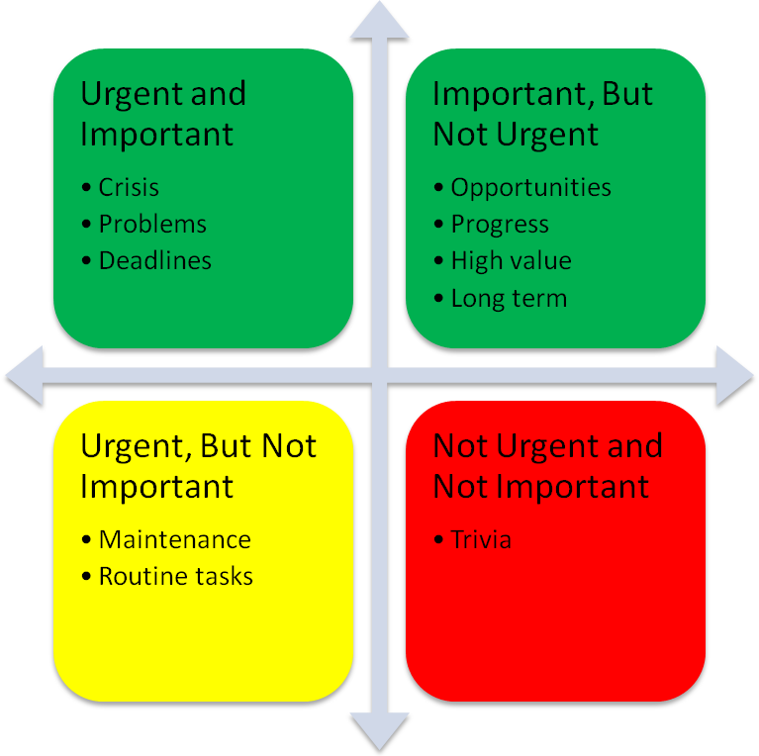  Urgent and Important: These tasks relate to dealing with critical issues as they arise. Perform these duties now.  Important, But Not Urgent: These success-oriented tasks are critical to achieving goals. Plan to do these tasks next.  Urgent, But Not Important: These chores do not help you achieve your own goals. Manage by delaying them and rejecting requests from others. Postpone these chores.  Not Urgent and Not Important: These trivial interruptions are a distraction. And should be avoided. Be careful not to mislabel things like time with family and recreational activities as not important. Avoid these distractions altogether. | Goal Setting  Setting a deadline gives you motivation to get started and having a timeframe (a realistic, achievable timeframe) enables you to plan the action steps required to achieve your goal by the deadline.  D – Defined  Define your goal explicitly, in precise detail. “I want to weigh 75kg” is specific. “I want to lose weight” is not.  A – Announce  Let others know, like your manager or project team.  R – Revised  Revise goal to meet the expectations of your manager or project team.  T – Timed Locked  Setting a deadline gives you motivation to get started and having a timeframe (a realistic, achievable timeframe) enables you to plan the action steps required to achieve your goal by the deadline.  So, you do have DART goals, you’re a motivated person, and capable of achieving the goals you set.  If you’re ticking all of the boxes above, but you have some goals that just remain unattained, here’s what you’re missing. Turn your goals into an OPUS.  O – Ownership  Is it really YOUR goal, or do you want it because it will make someone else happy?  P – Passion  Are you passionate about the goal? The passion is the fuel that gets you moving. If you’re not passionate about it, it’s not going to happen.  U – Urgency  Is it something you want to achieve NOW? Your goal should inspire an urge to act! If it’s something that would be nice to have some day, but not necessarily now, then it will stay on the back-burner until the time is right.  S – Significance  How important is it, really? If it’s just not that important to you, you won’t have the drive to make it happen.  Overcoming Procrastination  DELETE IT. What are the consequences of not doing the task at all? Consider the 80/20 rule; maybe it doesn’t need to be done in the first place.  DELEGATE. If the task is important, ask yourself if it’s something that you are responsible for doing in the first place. Know your job description and ask if the task is part of your responsibilities. Can the task be given to someone else?  DO IT NOW. Postponing an important task that needs to be done only creates feelings of anxiety and stress. Do it as early in the day as you can.  ASK FOR ADVICE. Asking for help from a trusted mentor, supervisor, coach or expert can give you some great insight on where to start and the steps for completing a project.  CHOP IT UP. Break large projects into milestones, and then into actionable steps. As Bob Proctor says, “Break it down into the ridiculous.” Huge things don’t look as big when you break it down as small as you can.  OBEY THE 15-MINUTE RULE. To reduce the temptation of procrastination, each actionable step on a project should take no more than 15 minutes to complete.  HAVE CLEAR DEADLINES. Assign yourself a deadline for projects and milestones and write it down in your day planner or calendar. Make your deadlines known to other people who will hold you accountable.  GIVE YOURSELF A REWARD. Celebrate the completion of project milestones and reward yourself for getting projects done on time. It will provide positive reinforcement and motivate you toward your goals.  REMOVE DISTRACTIONS. You need to establish a positive working environment that is conducive to getting your work done. Remove any distractions.

